**Curvilinear Coordinates  
Conformal Mapping**

Arely Miramontes1, Berenise Miramontes2

*1Computational Mathematics, University of New Mexico*

arelym@unm.edu

*2Computational Mathematics, University of New Mexico*

beremts12@unm.edu

***Abstract – In this report we discuss conformal mapping and plot the figure in two domains to check the error of area using integrals and the trapezoidal rule.***

***Keywords – MATLAB, Curvilinear Coordinates, Conformal Mapping, Trapezoidal Rule, Mapping, Error, Cartesian Coordinates, Polar Coordinates, Area transformation, linear transformation*.**

**I. INTRODUCTION**

A conformal map is a transformation $w=f(z)$ that preserves local angles. A complex function is said to be analytic on a region $R$ if it is complex differentiable at every point in $R$. Thus, an analytic function is conformal at any point where it has a nonzero derivative. Conversely, any conformal mapping of a complex variable which has continuous partial derivatives is analytic.

In this report we will take a rectangle in a Cartesian Coordinate plane and transform (map) it onto a Polar Coordinate Plane. We will then compare the Area transformation and call this the error.

**II. MAPPING**

Polar coordinates can be viewed as a way to determine the location of a point on the plane via the coordinates $(r,θ)$.

% Cartesian Coordinates (x,y)

x = 0:0.01:2.16; y = 1.56019*x;

% Polar Coordinates (r,theta)

r = 4;

theta = 45;

hold all

plot(x,y,'r-','MarkerSize',5)

plot(2.16,3.37,'b*','MarkerSize',7)

grid on

axis([-2 6 -2 6])

xlabel('x')

ylabel('y')

legend('r = 4','(x,y) = (2.16,3.37)')

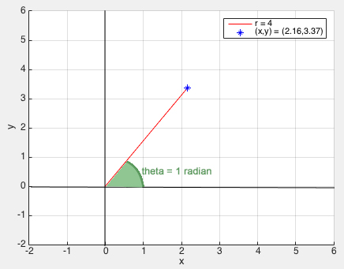

The polar coordinates $r$ and $θ$ are viewed above as two separate numbers. We can change our perspective by representing polar coordinates as a single point on a two-dimensional polar $(r,θ)$ plane. Since these polar coordinates are a single pair, we can treat them just like Cartesian coordinates and define an $r$-axis and $θ$-axis.

With this new perspective, polar coordinates is a mapping from a point $(r,θ)$ in the polar coordinate plane to the corresponding point $(x,y)$ in the Cartesian coordinate plane. The following plot helps visualize this new perspective.

grid on

axis([0 8 0 8])

xlabel('r')

ylabel('theta')

x1 = 0;

x2 = 6;

y1 = 0;

y2 = 6;

xx = [x1, x2, x2, x1, x1];

yy = [y1, y1, y2, y2, y1];

hold all

plot(xx,yy,'b-','LineWidth',3);

% Polar Coordinates (r,theta)

r = 4.07;

theta = 1;

plot(r,theta,'r*','MarkerSize',10);

legend('square','(r,theta) = (4.07,1)')

%Circle

%Center coordinates of Circle

xc = 0; yc = 0;

%Radius of circle

r = 6;

angle = 0:0.01:2*pi;

xp = r*cos(angle);

yp = r*sin(angle);

hold all

plot(xc+xp,yc+yp,'LineWidth',2)

axis([-7 7 -7 7])

grid on

xlabel('x')

ylabel('y')

xx = 0:0.01:2.2; yy = 1.55455*xx;

plot(xx,yy,'LineWidth',3)

x = 2.2; y = 3.42;

plot(x,y,'k*','MarkerSize',12)

legend('','r','(x,y) = (2.2,3.42)')

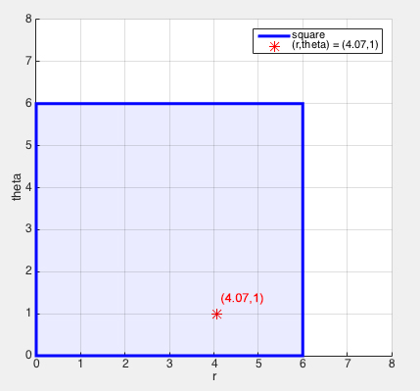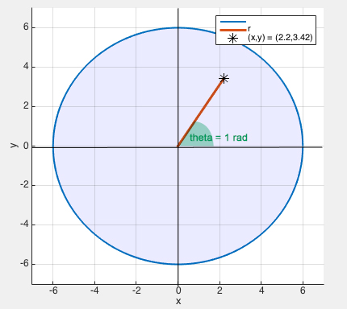

This new perspective allows us to explore the features of mapping. Now, we can use polar coordinates:

$$x=rcosθ$$

$$y=rsinθ$$

We can now write the mapping as a transformation $T$ defined by $\left(x,y\right)=T\left(r,θ\right)=(rcosθ,rsinθ)$. In the above plot we mapped the point $(r,θ)$ into the point $\left(x,y\right)=T(r,θ)$. We can gain additional intuition into the behavior of the polar coordinates mapping $T$ by looking at how it transforms a set of points.

For example, we can explore how polar coordinates maps a rectangle in the $(r,θ)$ plane. If a rectangle $D^{*}$ is defined by the domain $a≤r≤b$ and $c≤θ≤d$, it is mapped onto the Cartesian plane as a piece of a sector.

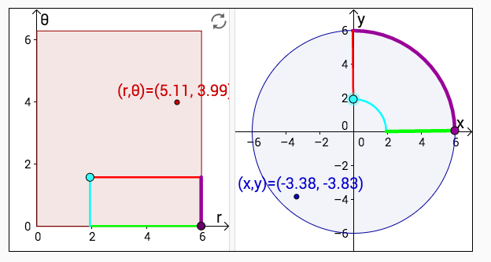

**III. AREA ERROR**

Now that we can see how the area of a rectangle is transformed to an annulus in Cartesian plane, we can see how the transformation affects the area.

This perspective of polar coordinates as a mapping allows us to look at how $T(r,θ)$ changes the area of regions as it maps it from the $(r,θ)$ plane to the $(x,y)$ plane. The shrinking of $T$ depends on the location $(r,θ)$. You can see in the following plot how it stretches more and more as $r$ increases, shrinking the area substantially for a very small $r$.

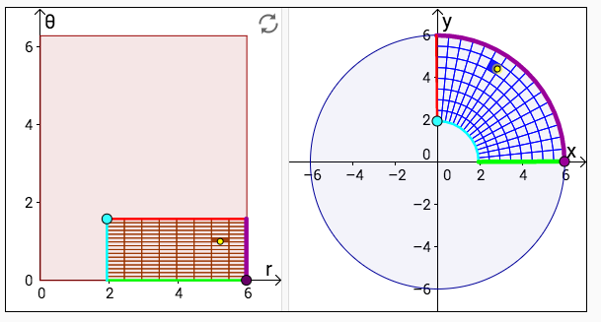

Now we want to see the difference of area between both figures. First, let us calculate the area in using double Integrals in Polar Coordinates.

$$\int{\int_{D}{f\left(x,y\right)dA, D is the disk of raduis 6}}$$

$$Now, we set our limits.$$

$$2≤x≤6$$

$$0≤y≤\sqrt{36-x^{2}}$$

$$With these limits, the integral wil now become:$$

$$\int{\int_{D}{f\left(x,y\right)dA=\int_{2}^{6}{\int_{0}^{\sqrt{36-x^{2}}}{f\left(x,y\right)dydx}}}}$$

$$We can now convert x and y to polar coordinates using the conversion:$$

$$x=rcosθ$$

$$y=rsinθ$$

$$Now, our new limits will become:$$

$$0≤θ≤\frac{π}{2}$$

$$2≤r≤6$$

$$dA=rdrdθ$$

$$Now our new integral is as follows:$$

$$\int_{0}^{\frac{π}{2}}{\int_{2}^{6}{rdrdθ}}$$

$$=\int_{0}^{\frac{π}{2}}{{\left.\frac{r^{2}}{2}dθ\right|}_{2}^{6}=\int_{0}^{\frac{π}{2}}{16dθ}}$$

$$={\left.16θ\right|}_{0}^{\frac{π}{2}}=8π$$

$$≈25.1327$$

Thus, we get the area to be $25.1327.$ Now, let us calculate the area by using the trapezoidal rule, and let us compare the results.

Using our previous function we created for the Trapezoidal Rule, we will calculate the area.

% c is the exact integral

disp(['--------------------------------'])

disp([' Step ', ' Approx ','Error'])

disp([' sizeh ',' solution ',''])

disp(['--------------------------------'])

valuesofErr = zeros(1,m);

for i=0 : m

m = 2^i;

h = (b-a)/m;

s = 0;

for k=1 : (m-1)

x = a+h*k;

s = s+feval(f,x);

end

s = h*(feval(f,a)+feval(f,b))/2+h*s;

err = abs(c-s);

valuesofErr(i+1) = err;

disp([h s err])

end

end

We use one function to review our data, $f\left(x\right)=\sqrt{16-x^{2}}$. We write our script file that grabs the Trapezoidal value and the value of the errors, and plot the error against n.

n = 10;

a = 2;

b = 6;

f = @(x) sqrt(16-x.^2);

c = integral(f,a,b)

[s,valuesofErr] = trapRule(f,a,b,n,c);

x = 1:1:n+1;

loglog(x,valuesofErr,'ro-','linewidth',3)

hold on

axis([0 n+1 0 1000])

xlabel('n')

ylabel('Maximum Error')

legend('Error for: {sqrt({16-x^2}})')

title('Trapezoidal Rule')

grid on

Thus, this is the error plot we get for the sector annulus.

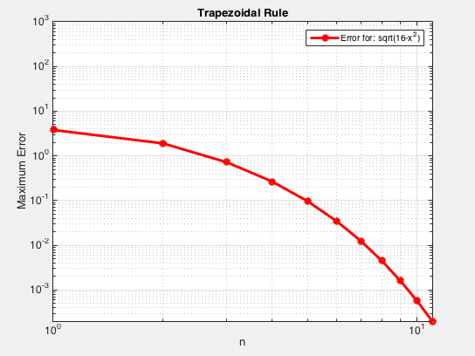

**IV. CONCLUSIONS**

The transformation from polar coordinates to Cartesian coordinates $\left(x,y\right)=T\left(r,θ\right)=(rcosθ,rsinθ)$ maps a rectangle $D^{*}$ in the $(r,θ)$ plane and it maps a “curved” rectangle, aka an annulus or sector in the $(x,y)$ plane. By looking at the plots you can see how the figures transform from one Domain to another.

The area has a small error when mapping points from one domain to another. Curvilinear coordinates can also be achieved with 3 variable functions.

**V. REFERENCES**

[1]: Appelo, Daniel. "Homework 3." *Math 471*. UNM, n.d. Web. <http://math.unm.edu/~appelo/teaching/Math471F15/html/Homework4.html>.